CHAPTER 1
INTRODUCTION

CHAPTER 1
INTRODUCTION

1.1 Introduction to composites
Over the last thirty years composite materials, plastics and ceramics have been the dominant emerging materials. The volume and number of applications of composite materials have grown steadily, penetrating and conquering new markets relentlessly. Modern composite materials constitute a significant proportion of the engineered materials market ranging from everyday products to sophisticated niche applications. While composites have already proven their worth as weight-saving materials, the current challenge is to make them cost effective. The efforts to produce economically attractive composite components have resulted in several innovative manufacturing techniques currently being used in the composites industry. It is obvious, especially for composites, that the improvement in manufacturing technology alone is not enough to overcome the cost hurdle. It is essential that there be an innovative change like modifying the reinforcement and using more cost effective fibers as reinforcements which decreases the weight and also has an optimum strength compared to convectional composites, to make them competitive to metals.

Definition of Composite
The most widely used meaning is the following one, which has been stated by Jartiz [1] “Composites are multifunctional material systems that provide characteristics not otainable from any discrete material. They are cohesive structures made by physically combining two or more compatible materials, different in composition and characteristics and sometimes in form”. The weakness of this definition resided in the fact that it allows one to classify among the composites any mixture of materials without indicating either its specificity or the laws which should given it which distinguishes it from other very banal, meaningless mixtures. Kelly [2] very clearly stresses that the composites should not be regarded simple as a combination of two materials. In the broader significance; the combination has its own distinctive properties. In terms of strength to resistance to heat or some other desirable quality, it is better than either of the components alone or radically different from either of them.
Beghezan [3] defines as “The composites are compound materials which differ from alloys by the fact that the individual components retain their characteristics but are so incorporated into the composite as to take advantage only of their attributes and not of their short comings”, in order to obtain improved materials. Van Suchetclan [4] explains composite materials as heterogeneous materials consisting of two or more solid phases, which are in intimate contact with each other on a microscopic scale. They can be also considered as homogeneous materials on a microscopic scale in the sense that any portion of it will have the same physical property.

Characteristics of the Composites
Composites consist of one or more discontinuous phases embedded in a continuous phase. The discontinuous phase is usually harder and stronger than the continuous phase and is called the ‘reinforcement‘ or ‘reinforcing material’, whereas the continuous phase is termed as the ‘ matrix’. Properties of composites are strongly dependent on the properties of their constituent materials, their distribution and the interaction among them. The composite properties may be the volume fraction sum of the properties of the constituents or the constituents may interact in a synergistic way resulting in improved or better properties. Apart from the nature of the constituent materials, the geometry of the reinforcement (shape, size and size distribution) influences the properties of the composite to a great extent. The concentration distribution and orientation of the reinforcement also affect the properties. The shape of the discontinuous phase (which may by spherical, cylindrical, or rectangular cross-sanctioned prisms or platelets), the size and size distribution (which controls the texture of the material) and volume fraction determine the interfacial area, which plays an important role in determining the extent of the interaction between the reinforcement and the matrix. Concentration, usually measured as volume or weight fraction, determines the contribution of a single constituent to the overall properties of the composites. It is not only the single most important parameter influencing the properties of the composites, but also an easily controllable manufacturing variable used to alter its properties.

Components of a Composite Material
In its most basic form a composite material is one, which is composed of at least two elements working together to produce material properties that are different to the properties of those elements on their own. In practice, most composites consist of a bulk material (the ‘matrix’), and a reinforcement of some kind, added primarily to increase the strength and stiffness of the matrix.

MATRIX
Many materials when they are in a fibrous form exhibit very good strength property but to achieve these properties the fibers should be bonded by a suitable matrix. The matrix isolates the fibres from one another in order to prevent abrasion and formation of new surface flaws and acts as a bridge to hold the fibers in place. A good matrix should possess ability to deform easily under applied load, transfer the load onto the fibers and evenly distributive stress concentration.
REINFORCEMENT
The role of the reinforcement in a composite material is fundamentally one of increasing the mechanical properties of the neat resin system. All of the different fibers used in composites have different properties and so affect the properties of the composite in different ways. For most of the applications, the fibers need to be arranged into some form of sheet, known as a fabric, to make handling possible. Different ways for assembling fibers into sheets and the variety of fiber orientations possible to achieve different characteristics.

INTERFACE
It has characteristics that are not depicted by any of the component in isolation. The interface is a bounding surface or zone where a discontinuity occurs, whether physical, mechanical, chemical etc. The matrix material must “wet” the fiber. Coupling agents are frequently used to improve wettability. Well “wetted” fibers increase the interface surfaces area. To obtain desirable properties in a composite, the applied load should be effectively transferred from the matrix to the fibers via the interface. This means that the interface must be large and exhibit strong adhesion between fibers and matrix. Failure at the interface (called debonding) may or may not be desirable.
In addition to these the composite contains very small amounts of catalyst and accelerator which are added to increase the bonding between the reinforcement and matrix.

CLASSIFICATION
Composite materials can be classified into many categories depending on the type of matrix material, reinforcing material type etc.

- According to the type of matrix material they can be classified as follows:

Polymer Matrix Composites (PMC’s) –
These are the most common of all types of composites because of their ease of production and manufacturing coats. Also known as FRP - Fiber Reinforced Polymers - these materials use a polymer-based resin as the matrix, and a variety of fibers such as glass and carbon as the reinforcement. For example “fiberglass”, the first successful modern composites, is one of the polymer matrix composites. It is used for making boat hulls, storage tanks, pipes, and car components.

Metal Matrix Composites (MMC’s) –
Increasingly found in the mobile industry, these materials use a metal such as aluminum as the matrix, and reinforce it with fibers such as silicon carbide.

Ceramic Matrix Composites (CMC’s) –
Used in very high temperature environments, these materials use a ceramic as the matrix and reinforce it with short fibers, such as those made from silicon carbide and boron nitride.

- According to the type of reinforcing material type they can be classified into the following categories:

Particulate composites:
particulate reinforced composites consist of a matrix reinforced by a dispersed phase in the form of particles. It can be either of random orientation or preferred orientation.

Fibrous composites:
1) Short fibrous: they consist of a matrix reinforced by a dispersed phase in the form of discontinuous fibers either of random or preferred orientations.
2) Long fiber- they consist of a matrix reinforced by a dispersed phase in the form of continuous fibers. They can be either unidirectional or bidirectional.

Laminate composites:
when a fiber reinforced composite consists of several layers with different fiber orientations, it is called multilayer composite.

1.2 TYPES OF FIBERS:
There are two types of fibers used as reinforcements in fibrous composites. They are:-
- Synthetic fiber
- Natural fibers

Synthetic fibers:-
Synthetic fibers are the result of extensive research by scientists to improve on naturally occurring animal and plant fibers. In general, synthetic fibers are created by forcing, usually through extrusion, fiber forming materials through holes (called spinnerets) into the air, forming a thread.
Synthetic fibers are made from synthesized polymers or small molecules. The compounds that are used to make these fibers come from raw materials such as petroleum based chemicals or petrochemicals. These materials are polymerized into a long, linear chemical that bond two adjacent carbon atoms. Differing chemical compounds will be used to produce different types of fibers. Although there are several different synthetic fibers, they generally have the same common properties. Generally, they are known for being:
- Heat-sensitive
- Resistant to most chemicals
- Resistant to insects, fungi and rot but when damp and warm may attract them
- Low moisture absorbency
- Electrostatic
- Flame resistant
- Density or specific gravity
- Pilling
- Low melting temperature
- Extremely hazardous to the environment.
- Can shrink wrap and suffocate the user.
- Can make you overheat
- Synthetic fibers do not depend either on an agricultural crop or on animal farming.
- They are generally cheaper than natural fiber.
- Synthetic fibers possess unique characteristics which make them popular dress material.
- They dry up quickly, are durable, readily available and easy to maintain.
- Can make you get cold when wet
The most commonly used synthetic fibers are E-Glass, S-Glass and carbon.
Natural fibers:-
Generally, natural fibers are considered as naturally occurring composites consisting mainly of cellulose fibrils embedded in lignin matrix. These cellulose fibrils are aligned along the length of the fiber, irrespective of its origin. The composition of a few natural fibers is as shown in Table 1.1.
Advantages:-
- Less cost
- More availability
- Bio-degradable
Even though natural fibers have many advantages, their use is restricted because of several limitations. They are incompatible with some polymeric matrices, have high absorption and have poor wettability . These are the problems faced even when the natural fibers are used in hybrid composites. In order to overcome these problems, chemical treatments are done. To this end, the present research work is undertaken to study the effects of Hybridization of jute composite with glass on the mechanical properties and performance of fiber reinforced composite.

Classification of Natural fibers:-
Based on origin, natural fibers can be classified into three categories that are plant fibers, animal fibers and mineral fibers. The detailed classification of the fibers is as shown in Figure 1.2.
Fig1.2: Classification of natural fibers
The mechanical properties of some natural fibers compared with most commonly used E-glass fiber is shown in Table 1.2. It is evident from the table that even though the modulus of natural fibers is similar to glass fibers, the tensile strength of glass fibers is much higher than the natural fibers. However, the specific modulus (modulus/ specific gravity) of both glass as well as natural fibers are comparable and in some cases, the value for natural fibers is even better than glass fibers. These higher specific properties are one of the main advantages of using natural fiber as reinforcement in polymer composites for applications where one of the aims is reduction of weight.
1.3 HYBRID COMPOSITES
When more than one type of fibers is reinforced into a common matrix, the resulting composite is called hybrid composite. Hybrid composites provide greater freedom when it comes to designing composites for specific properties as compared to single fiber reinforced composites. Recently, natural fibers such as bamboo, jute etc. has been mixed with synthetic fibers such as glass to form hybrid composites with desired properties at low cost. The behavior of hybrid composites is a weighed sum of individual components in which there is a more favorable balance between the inherent advantages and disadvantages. By using hybrid composites, the advantages of one type of fiber could compliment what is lacking in the other fiber. The properties of hybrids are decided by many factors such as fiber content, fiber length, orientation, extent of intermingling of fibers, fiber to matrix bonding etc.

1.4 ADVANTAGES OF COMPOSITES MATERIALS:
Composites have actually been in use for thousands of years. Adobe bricks were made using a composite of mud and straw. It is the combination of the physical properties of each material that gives the composite material many of its physical characteristics. Today’s advanced composites, like carbon fiber, bring together combined properties we’ve come to know – lightweight, strong, durable and heat-resistant. Today, the benefits of components and products designed and produced in composite materials – instead of metals, such as aluminum and steel – are well recognized by many industries. Some of the advantages include:

High Strength-to-weight ratio | Corrosion Resistance
Wear Resistance | Stiffness
Fatigue Life | Temperature-Dependent Behavior
Thermal Insulation | Thermal Conductivity
Acoustical Insulation | Low-Electrical Conductivity
Visual Attractiveness | Radio translucent

WEIGHT REDUCTION:
Weight reduction using composites has created a huge market demand in automotive, industrial, aerospace and other industries. None is more visible than the commercial airline industry. Due to the high cost of aviation fuel, aircraft manufacturers are now competing based upon their aircraft’s fuel efficiency. In recent years, these manufacturers have turned to the use of lightweight composites in their designs without having to compromise strength and durability for almost every component of their aircraft. The resulting weight reduction that is realized by using composite materials translates into considerable cost savings in terms of fuel.
Aircraft
In aircraft design carbon fiber composites, hybrid composites, and composite reinforced plastics are being used in more and more sections of the aircraft, including:
- Engine Nacelles
- Seating and Interior Finishes
- Horizontal and Vertical Stabilizers
- Rudders
- Ailerons
- Floor Beams
- Elevators
- Front and Main Landing Gear Doors
- Wing to Fuselage Fairings
- Full Fuselage and Wing Assemblies
- Composite Resources has played an important role in commercial aircraft design, developing and producing components for the commercial airline seat frame market.
Carbon fiber composites and hybrid composites are roughly one-half the weight of aluminum and one-quarter the weight of steel. As noted above, a lightweight composite component makes it more desirable to engineers developing a wide variety of products and parts. The days are long gone when it was considered that the heavier the product the better the quality.

SRENGTH AND DURABILITY:
Durability is a property of composites that is often overlooked. Most who know about composites are aware of the strength and weight advantages. Stock and custom products developed and produced here at Composite Resources are manufactured from a variety of composite and hybrid composite materials. Composites are very versatile – our designers can select from a broad range of resins and fibers to attain the preferred material properties, in terms of strength, durability, and other characteristics.
Carbon fiber composites and hybrid composites have numerous advantages over steel, aluminum, and other metals. When compared to steel and aluminum, composites have superior mechanical properties, including higher specific strength (the strength rating divided by the density factor) and higher specific stiffness (stiffness rating divided by the density factor).
Composite materials deliver greater strength than various grades of aluminum, and equivalent strength to steel. In addition, composites’ strength can be improved, depending on the materials, fiber orientation (bi-directional or unidirectional), and various fiber lay-up angles that are used. Carbon fiber composites (as well as other hybrid composites) with high specific strengths can handle and carry very high loads.
For industrial and recreational projects and components, composites will outperform metals, offering more durability in any sort of harsh and corrosive environment. Composites’ strength and stiffness properties are also superior to aluminum and steel, and can be formed, machined and fabricated into practically any specification required.

Type of composites prepared in this research:-
- Long fibrous Unidirectional composite
Orientation of fiber angle is 90$°$ and there are continuous in longitudinal direction throughout the length of the material.
- Polymer Matrix Composite
The matrix used is general purpose polyester, which is an organic polymer.
Therefore, the composite materials obtained are orthotropic materials because the reinforcement is in only one direction that is the fiber reinforcement has an impact majorly in one direction.

1.5 INTRODUCTION TO ANSYS:
ANSYS is a general purpose finite element modeling package or numerically solving a wide variety of mechanical problems. These problems include: static/dynamic structural analysis (both linear and non-linear), heat transfer and fluid problems, as well as acoustic and electro-magnetic problems.
PROGRAM ORGANISATION:
The ANSYS program is organized into basic levels:
- Begin level
- Processor(or routine)level
The begin level acts as a gateway into and out of the ANSYS program. It is also used for certain global program controls such as changing the job name, clearing (zeroing out) the database, and copying binary files. When you first enter the program, you are at the begin level.
At the processor level, several processors are available. Each processor is a set of functions that perform a specific analysis tasks. For example, the general processor (PREP7) is where you build the model, the solution processor(SOLUTION) is where you apply loads and obtain the solution, and the general postprocessor (POST1) is where you evaluate the results of a solution. An additional postprocessor, POST26, enables you to evaluate solution results at specific points in the model as function of time.
Material Models:
ANSYS allows several different material models like:
- Linear elastic material models (isotropic, orthotropic and anisotropic).
- Non-Linear material models (hyper elastic, multi linear elastic, inelastic and visco elastic).
- Heat transfer material models (isotropic and orthotropic).
- Temperature dependent material properties.
- Creep material models.

Loads:
The word loads in ANSYS terminology includes boundary conditions and externally or internally applied forcing functions, as illustrated in loads. Examples of loads in different disciplines are:
- Structural: displacements, forces, pressures, temperature (for thermal strain), gravity.
- Thermal: temperatures, heat flow rates, convections, internal heat source current density, infinite surface.
- Magnetic: magnetic potentials, magnetic flux, magnetic current segments, source current density, infinite surface.
- Electric: electrical potential (voltage), electric current, electric charges, charge densities, infinite surface.
- Fluid: velocities, pressures loads are divided into six categories: DOF constraints, forces (concentrated loads), surface loads. Body loads, inertia loads and coupled field loads.
- A DOF constraint fixes a degree of freedom (DOF) to know value. Examples of constraints are specified displacements and symmetry boundary conditions in a structural analysis, prescribed temperatures in a thermal analysis and flux parallel boundary conditions.
- A force is a concentrated load applied at a node in the model. Examples are forces and moments in a structural analysis, heat flow rates in a thermal analysis and current segments in a magnetic field analysis.
- A surface load is a distributed load applied over a surface. Examples are pressure in a structural analysis and convection and heat fluxes in a thermal analysis.
- A body load is a volumetric or field load. Examples are temperatures and in fluencies in a structural analysis that generation rates in a thermal analysis and current densities in a magnetic field analysis.
- Inertia loads are those attributable to the inertia (mass matrix) of a body, such as gravitational acceleration, angular velocity and angular acceleration. These are used mainly in a structural analysis.
- Coupled field loads are simply a special case of one of the above loads, where results from one analysis are used as loads in another analysis. For example, magnetic forces can be applied to calculate in a magnetic field analysis as force loads in a structural analysis.

ANALYSIS TYPES:
The following types of analysis are possible using ANSYS
- Structural Analysis: Static Analysis, Model Analysis, Harmonic Analysis, Transient Dynamic Analysis, Spectrum Analysis, Buckling Analysis, Explicit Dynamic Analysis, Fracture Mechanics and Beam Analysis.
- Thermal Analysis: Steady-state thermal Analysis, Transient Analysis.
- CFD (Computational Fluid Dynamics) Analysis: Laminar or turbulent, Thermal or adiabatic, free surface, compressible or incompressible, Newtonian or Non-Newtonian, Multiple Species transport.
- Several types of Electromagnetic field analysis and coupled field analysis.

PROCESING:
Post processing means reviewing the results of an analysis. It is probably the most important step in the analysis, because you are trying to understand how the applied loads affect your design, how good your finite element mesh is and so on.
Two post processors are available to review your results: POST1, the general post processors and POST26, the time-history post processor. POST1 allows you to review the results over the entire model at specific load steps and sub steps (or at specific time-points or frequencies). POST26 allows you to review the variation of a particular result item, specific points in the model with respect to time, frequency or some other result item. In a transient magnetic analysis for instance you can graph the eddy current in a particular element versus time. Or, in a non linear structural analysis, you can graph the force a particular node versus its deflection.

SYSTEM CONFIGURATION:
In the present work, the computational numerical analysis is done using ANSYS version 12.0 running on Pentium IV system with windows XP operating system.

1.6 Thesis Outline:
The remaining of this thesis is organized as follows:
Chapter 2: Previous work relevant to the present research is described in this chapter.
Chapter 3: This chapter describes the details of materials required; fabrication techniques and characterization of the composites under investigation are presented. The rules of mixture are discussed for prediction of strength of composites. The sample modeling was also been included which is used for simulation in ANSYS for tensile behavior.
Chapter 4: The mechanical behavior of jute/glass fiber reinforced plastics and their hybrid composites are presented, and compared to the results obtained in simulation & by rule of mixtures this chapter.
Chapter 5: Conclusions and recommendations for future work are presented in this chapter.

CHAPTER 2
LITERATURE SURVEY

CHAPTER 2
LITERATURE SURVEY

2.1literature Review:
The idea of this chapter is to provide the background information on the current research trends on the hybrid composites with special attention on the jute fiber based polymer composites.
A number of investigations have already been carried out on several types of natural fibers such as hemp, flax, bamboo, jute and kenaf to study the effect of these fibers on the mechanical characteristics of composite materials [4-7]. In dynamic mechanical analysis, Laly et al. [8] have reported on banana fiber reinforced composites and obtained that the optimum percentages of banana fiber is 40wt.%. Effect of fiber content on tensile and flexural properties of pineapple fiber reinforced poly (hydroxybutyrate-co-valerate) resin composites has been studied by Luo and Netravali [9]. The mechanical behavior of jute and kenaf fiber reinforced polypropylene composites has been studied by Schneider and Karmaker [11].

2.2 Knowledge gap:
It can be seen from the above survey that although an exhaustive amount of research has been done on the evaluation of mechanical properties of natural fiber reinforced composites, the research done on evaluation of mechanical properties of hybrid composites is very less.

2.3 Objectives of the present research work:
Following are the objectives that have been outlined keeping in mind the knowledge gap:
1. Fabrication of a new class of polyester based hybrid composite reinforced with long jute- glass fibers and convectional composites made form pure glass and jute by varying volume fraction in the resin of polyester.
2. Evaluation of mechanical properties such as tensile strength, flexural strength and Impact Strength of jute- glass hybrid composites and compare their strength against the convectional composites made of pure glass and jute.
3. To compare the results obtained by ANSYS and experimentation to that of the theoretical results in case of tensile test.
4. To compare experimental results to that of the theoretical results in case of flexural and also to obtain Impact strength experimentally.
5. To predict the shear modulus and passions ratio in different planes by using rules of mixture.
6. To draw a conclusion on the different properties of composite materials with respect to varying volume fraction.
2.4 Outline for research work:
- Identification of methods and materials.
- Procurement of raw materials (fiber and resin).
- Refinement of raw fiber (jute and glass).
- Preparation of composites and curing.
- Experimentation on the samples prepared and documentation of the results.
- Simulation for tensile strength in ANSYS and documentation of the analysis.
- Comparing the results of ANSYS and experimentation to that of the theoretical results.

CHAPTER 3
METHODS AND MEANS

CHAPTER 3
METHODS AND MEANS
As stated above a view on the mechanical behavior of the composites can be obtained in three different ways:-
- By predicting the strength of the composite using theoretical formulas.
- By experimenting on the composite by preparing them.
- By simulating them in the ANSYS software.
In this research work we mainly focus on the experimental work on the composites because this method gives the actual and reliable values. After which we compare them with the theoretical and stimulated values to draw conclusions and obtain the deviations.
Let’s review one by one of the three methods used:-
3.1 METHOD FOR THEORETICAL EVALUATION OF MECHANICAL PROPERTIES FOR COMPOSITES:
The theoretical methods are used for predicting the values of strength of composites. In this research work the RULE OF MIXTURE are used for predicting the strength of the composite. The rules of mixture are assumed to be a good fit for the actual strength for the composite materials.
RULE OF MIXTURE
It is based on SIMPLE MICROMECHANICAL MODELS. This simplest method of estimating the stiffness of a composite in which all of the fibers are aligned in the direction of the applied load (a unidirectional composite) is to assume that the structure is a simple beam, as in Figure 3.2.1, in which the two components are perfectly bonded together so that they deform together. We shall ignore the possibility that the polymer matrix can exhibit time-dependent deformation. The elastic (Young) moduli of the matrix and reinforcement are Em and Ef, respectively. We let the cross-sectional area of the fiber ‘component’ be Af and that of the matrix component be Am. If the length of the beam is L, then we can represent the quantities of the two components in terms of their volume fractions, Vf and Vm , which is more usual, and we know that their sum Vf + Vm = 1. The fiber volume fraction, Vf, is the critical material parameter for most purposes. The subscript ‘c’ refers to the composite.
Young’s modulus:-
The load on the composite, Pc, is shared between the two phases, so that Pc = Pf + Pm, and the strain in the two phases is the same as that in the composite, εc = εf = εm (ie. this is an ‘iso-strain’ condition).
Since stress = load/area, we can write:
σcAc = σfAf + σmAm
And from the iso-strain condition, dividing through by the relevant strains, we have:
$$\frac{σ_{c}A_{c}}{ε_{c}}=\frac{σ_{f}A_{f}}{ε_{f}}+\frac{σ_{fA_{f}}}{ϵ_{m}}$$
$E_{C}=E_{f}V_{f}+E_{m}(1-V_{f})$……………….. (3.1)

This equation is referred to as the Voigt estimate, but is more familiarly known as the rule of mixtures.

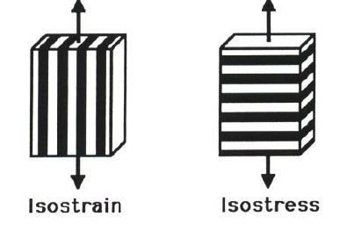

Fig: 3.1 showing the Isostress an Isostrain condition for simple unidirectional composite
Fig3.2.1: Simple parallel model of unidirectional composite
Fig3.2.2: Simple series model of unidirectional composite

To estimate the transverse modulus, $E_{t}$, we use a similar approach with a block model such as that shown in Figure 3.2.2, with the same constraints as before, i.e. well-bonded components with similar Poisson ratios, and no visco-elastic response from the matrix. This is now an ‘iso-stress’ model, so that σc = σf = σm. The total extension of the model is the sum of the extensions of the two components:
εcLc = εf Lf + εm Lm
If the cross-sections of both phases are the same, L ≡ V, so dividing through by the stress (and remembering that Vf + Vm = 1) we have:
$\frac{ε_{c}}{σ_{c}}=\frac{ε_{f}v_{f}}{σ_{f}}+\frac{ε_{m}v_{m}}{σ_{m}}$………………. (3.2)
or $\frac{1}{E_{t}}=\frac{V_{f}}{E_{f}}+\frac{V_{m}}{E_{m}}$

This is referred to as the Reuss estimate, sometimes called the inverse rule of mixtures.

$E_{1}$ is also called as $E_{l}$.
$E_{2}$ is also called as $E_{t}$.

Poisson’s ratio: -
The Poisson ratio, ν, of an isotropic material is defined as the (negative) ratio of the lateral strain,$ε_{1}$ when a stress is applied in the longitudinal (x1) direction, divided by the longitudinal strain, $ε_{1}$. i.e $ϑ=-{ε_{2}}/{ε_{1}}$. Consideration of equations 3.1 and 3.2 shows that in a unidirectional composite lamina there will be two in-plane Poisson ratios, not one as in isotropic materials, and it is convenient to label these $ϑ_{12}$, called the major Poisson ratio (relating to the lateral strain, $ε_{2}$, when a stress is applied in the longitudinal ($x_{1}$ direction) and $ϑ_{21}$, the minor Poisson ratio (relating to the strain in the $x_{1}$direction when a stress is applied in the $x_{2}$ direction). The two are not the same, since it is obvious that $ϑ_{12}$ must be much larger than $ϑ_{21}$. By means of arguments similar to those above for the determination of $E_{1}$, it can be shown that for a stress applied in the x1 direction only, the major Poisson ratio is given by:
$ϑ_{12}= ϑ_{f}V_{f}+ϑ_{m}(1-V_{f}$)…………….3.5

ie. It also obeys the rule of mixtures. Further thought will show that the minor Poisson ratio must be related to $ϑ_{12}$by the equation:
$ϑ_{21}=\frac{E_{2}}{E_{1}}ϑ_{12}$……………3.6

Values of the fiber and matrix Poisson ratios rarely differ by a great deal, so that neither matrix nor fiber characteristics dominate these two elastic constants.

In-plane shear modulus ($G_{12}$):-
Fig: 3.3 Definition shear relative to the $X_{1},X_{2}$Cartesian axis
When a unidirectional fiber composite is loaded by an in plane($X_{1},X_{2}$) shear force, it distorts to a parallelogram, as shown in Figure 3.3. The shear stress in the fiber direction,$τ_{12}$, is matched by its complementary shear stress, $τ_{21}$. The simplest model assumes that the fibers and matrix carry the same stress:
and the (apparent) in-plane shear modulus, $G_{12}$, is given by:
$\frac{1}{G_{12}}=\frac{V_{f}}{G_{f}}+\frac{(1-V_{f})}{G_{m}}$……..3.5
By analogy with equation 3.2 for the transverse Young's modulus, it can be seen that the matrix shear stiffness again dominates the composite shear modulus unless the fiber volume fraction is very large.
Table 3.1 List Of Formulas For Theoretical Evaluation Of Mechanical Behavior Of Composites:-
PROPERTIES | FROMULAS
Young's modulus in Longitudinal direction | $$E_{C}=E_{f}V_{f}+E_{m}(1-V_{f})$$
Young's modulus in Transverse direction | $$\frac{1}{E_{t}}=\frac{V_{f}}{E_{f}}+\frac{V_{m}}{E_{m}}$$
Poisson ratio in Longitudinal direction | $ϑ_{12}= ϑ_{f}V_{f}+ϑ_{m}(1-V_{f}$)
Poisson ratio in transverse direction | $$ϑ_{21}=\frac{E_{2}}{E_{1}}ϑ_{12}$$
In-plane Shear modulus | $$\frac{1}{G_{12}}=\frac{V_{f}}{G_{f}}+\frac{(1-V_{f})}{G_{m}}$$

3.2 METHOD FOR EVALUATION OF ACTUAL MECHANICAL PROPERTIES FOR COMPOSITES:
The process chosen for the evaluation of actual mechanical properties of composite is experimentation.
This process is subdivided into three phases:-
- Procurement and refinement of raw materials.
- Preparation of test samples for experimentation(Tensile, Flexural & Impact)
- Testing procedure

Let’s review one by one in-detail:-
Procurement and refinement of raw materials:
Three main raw materials are used.

1) Jute:
This obtained in form of heaps with inclusions. This raw jute must be combed to obtain unidirectional long thin fibers.
- Content:-Cellulose(Wt %) 61.1-71.5; Hemicelluloses(Wt %) 13.6-20.4; Lignin(Wt %) 12-13; Moisture Content(Wt %) 12.5-13.7
- Mechanical properties:- young's modulus- 20e3MPa; poisons ratio:-0.38;
Density:-1.3-1.45 g/${cm}^{3}$; Shear Modulus- 7.24GPa
2)E- Glass:
This is obtained in form of tape; Glass tape is chosen over Glass sheet because a glass tape is less tamper and more polished the glass sheet. The fibers are pulled slowly and gently form the Glass tape.
- Contents:-SiO2 52-60%;CaO 16-25%;Al O312-16%;BaO8-13%.
- Mechanical properties: young's modulus- 70e3MPa; poisons ratio:- 0.2
Density:-2.53 g/${cm}^{3}$; Shear Modulus- 28-32GPa
3) General purpose polyester resin:
Ecmalon 4413 is a general purpose unsaturated polyester resin of medium reactivity. The resin has medium viscosity and the moldings are rigid. It is ideally suited for moldings using wet lay-up. This is used has matrix here.
- Mechanical properties: young's modulus- 3e3MPa; poisons ratio:- 0.46 Density:-1.13 g/${cm}^{3}$; Shear Modulus- 1.4GPa
Ratio in which the mixture is prepared is Resin: Accelerator: Catalyst = 100:1.5:1.5
i.e. Resin: 100g
2% Cobalt Accelerator: 1.5ml
50% MEKP (Methyl ethyl ketone peroxide): 1.5ml
The polyester resin is mixed with the accelerator and catalyst because theses speeds the solidification process and aids the bounding between the fiber and the matrix.
The raw materials in their raw form are presented in figures 3.4 and 3.5. The raw materials in refined form are presented in figures 3.6.

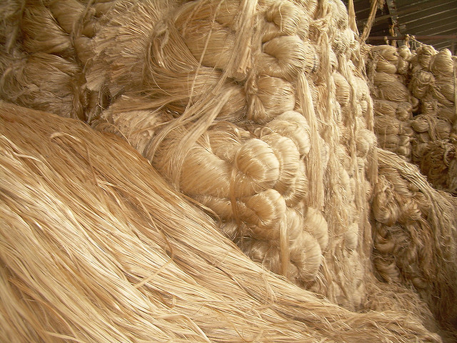
Fig: 3.4 Raw jute
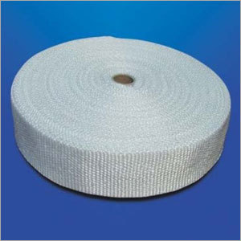

Fig: 3.5 Glass Tape
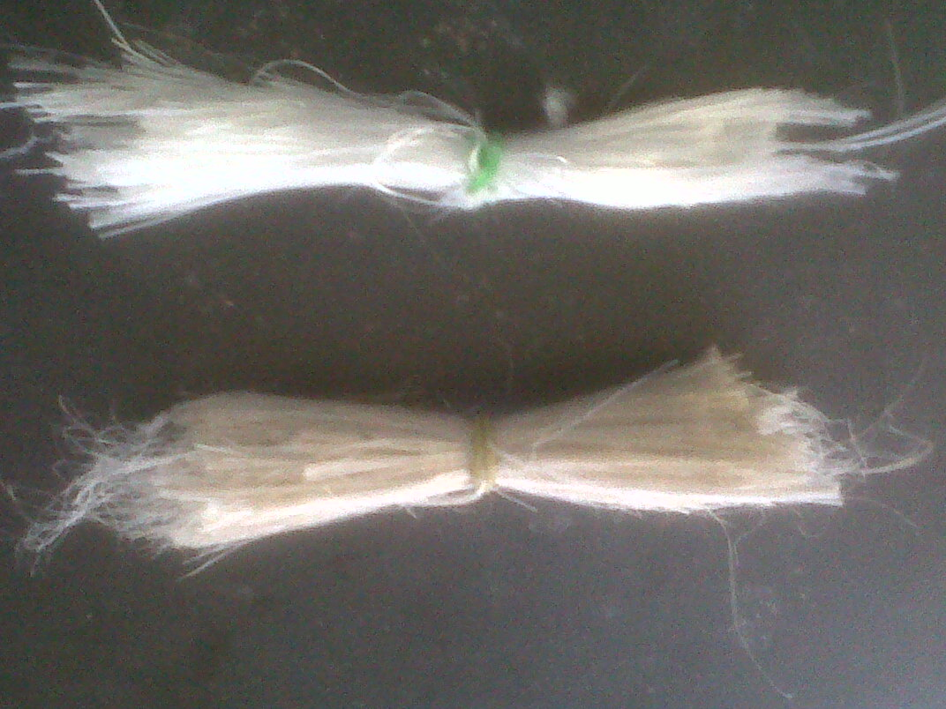

Fig: 3.6 Refined fibers ready to use
Preparation of test samples for experimentation (Tensile, Flexural & Impact):
- A rubber mould is prepared on a smooth tile according to the type of sample prepared.
Table 3.2 Test sample dimensions with respect to type of test:
Test | Dimensions of mould in mm
Tensile test | 160*10*3
Flexural test | 100*25*3
Impact test | 63.5*12*10

- Raw Jute & Glass fibers are refined and are cleaned to take out any impurities.
- The resin is mixed thoroughly with accelerator & catalyst according to the ratio stated above.
- Then the sample is prepared by mixing calculated ratios of fiber & resin by simple hand-lay-up technique.
- Care should be taken to cut the fibers to the desired length exactly.

Nine different sample are prepared by varying the volume percentage of the fiber in the resin.
The sample number and respective composition are given below:-
Table 3.3 Test sample composition in volume fraction:
Test sample number | Volume fractions in %  (JUTE:GLASS:RESIN)
Sample 1 | JUTE=25%:GLASS=0%:RESIN=75%
Sample 2 | JUTE=15%:GLASS=10%:RESIN=75%
Sample 3 | JUTE=10%:GLASS=15%:RESIN=75%
Sample 4 | JUTE=0%:GLASS=25%:RESIN=75%
Sample 5 | JUTE=15%:GLASS=0%:RESIN=85%
Sample 6 | JUTE=10%:GLASS=0%:RESIN=90%
Sample 7 | JUTE=0%:GLASS=15%:RESIN=85%
Sample 8 | JUTE=0%:GLASS=10%:RESIN=90%
Sample 9 | JUTE=0%:GLASS=0%:RESIN=100%

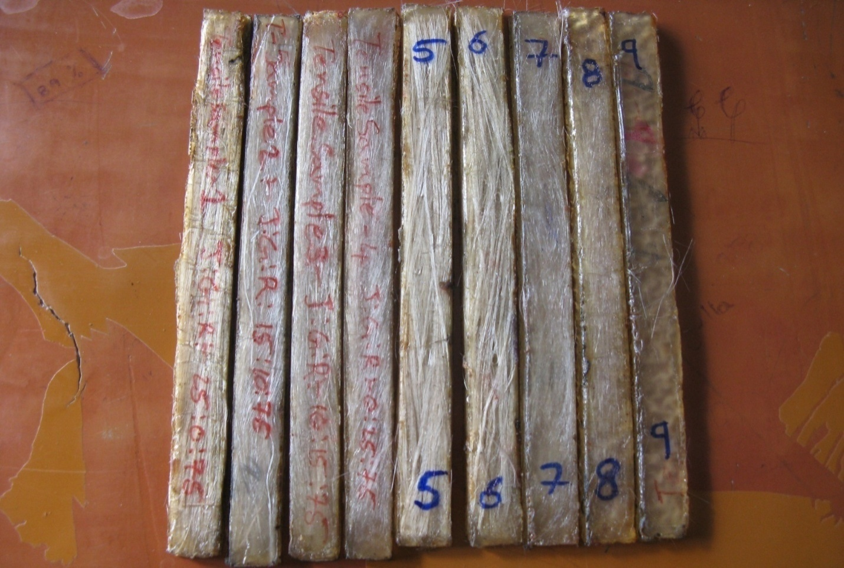

Fig: 3.7 Tensile Test Samples
(Span Length Is 100 mm)
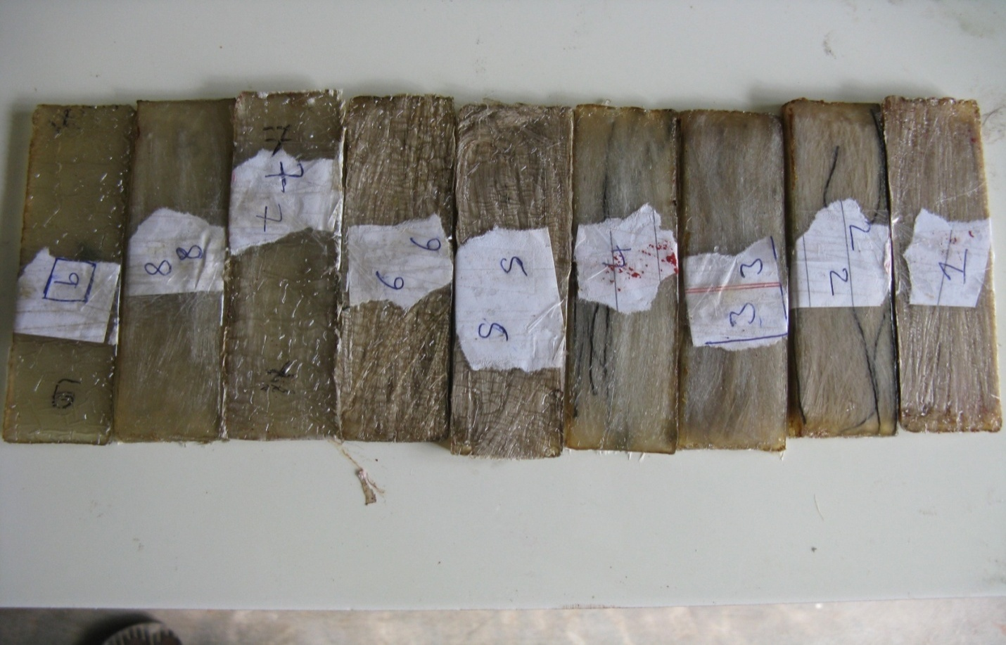
Fig: 3.8 Flexural Test Samples
(SPAN LENGTH IS 70mm)
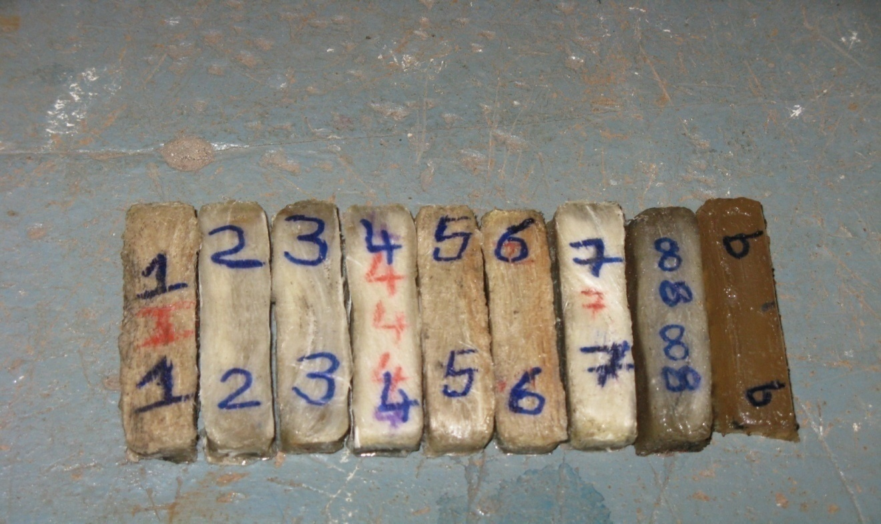
Fig: 3.9 IMAPCT TEST SAMPLES
(A 2mm thick grove is made on the 10mm width side)
The figure 3.7, 3.8 and 3.9 shows the nine different test samples with varying composition for tensile, flexural and Impact.
TESTING PROCEDURE:-
Before going to the testing procedures let’s review the most important terms used in this discussion.
Tensile Strength:-
Ultimate tensile strength (UTS), often shortened to tensile strength (TS) or ultimate strength, is the maximum stress that a material can withstand while being stretched or pulled before failing or breaking. Tensile strength is the opposite of compressive strength and the values can be quite different.

Flexural Strength:-
Flexural strength, also known as modulus of rupture, bend strength, or fracture strength, it is a mechanical parameter for brittle material, is defined as a material's ability to resist deformation under load. The transverse bending test is most frequently employed, in which a rod specimen having either a circular or rectangular cross-section is bent until fracture using a three point flexural test technique. The flexural strength represents the highest stress experienced within the material at its moment of rupture.
Impact Strength:-
The ability of a plastic to withstand high energy impact without fracturing or breaking. Izod impact testing is an ASTM standard method of determining impact energy. A notched sample is generally used to determine impact energy.
The tensile test and flexural test are performed on tensile testing machine which has the flexibility to change the testing fixture for tensile and flexural test respectively. Which gives the load in Kilograms and elongation in mm. Impact test is measured by using Izod Impact testing machine which gives the energy absorbed in Joules.
Figure 3.10, 3.11 and 3.12 shows the tensile test, flexural test and impact test respectively.

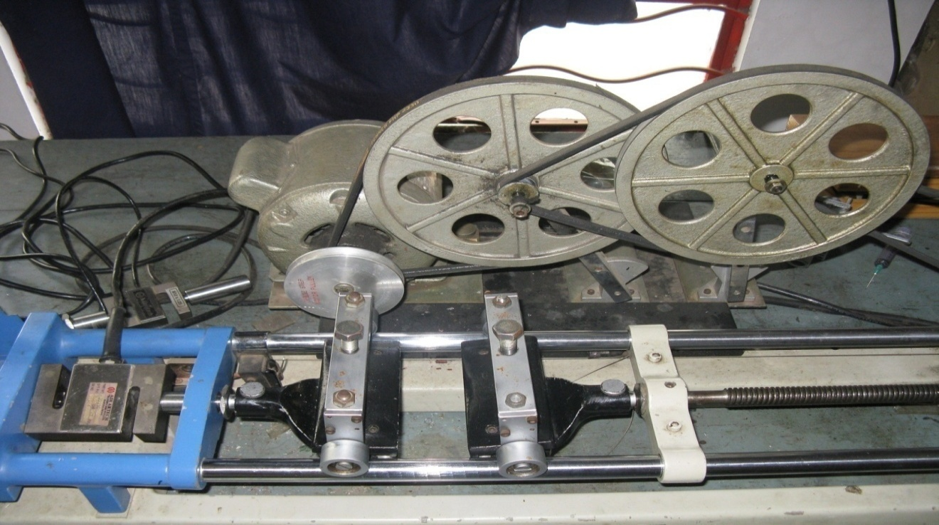
Fig: 3.10 Tensile Testing Machines in Unloaded Condition
(With tensile testing fixtures)

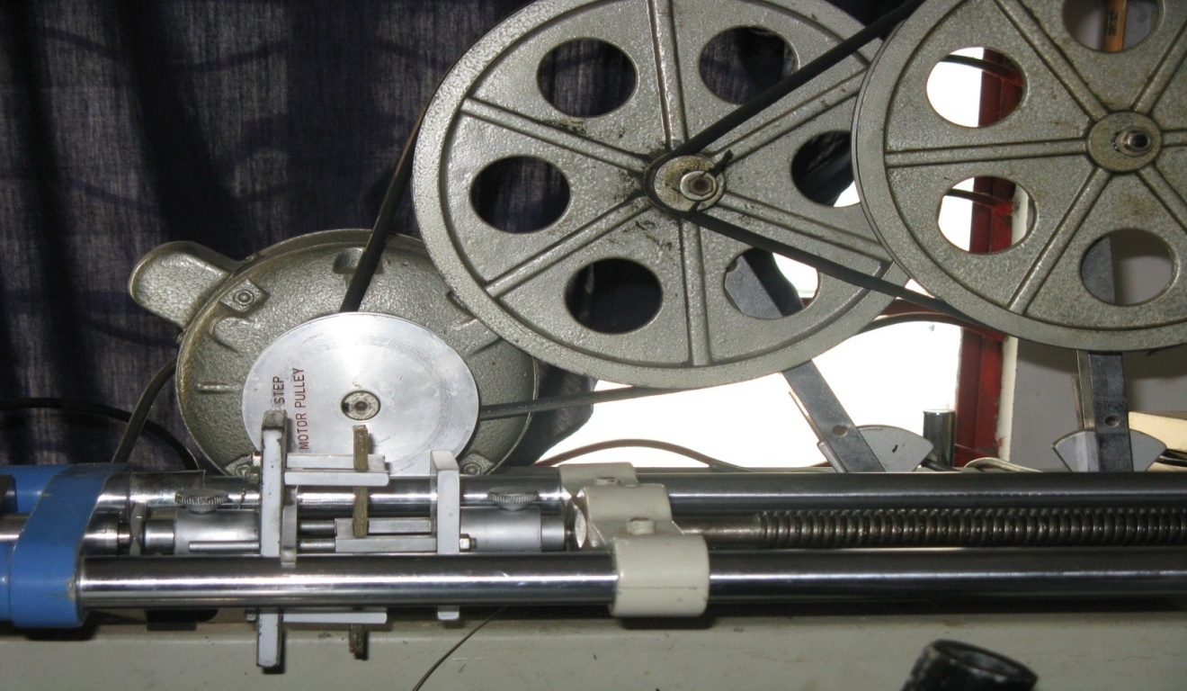
Fig: 3.11Tensile Testing Machine Performing Flexural Test
(Equipped with 3-point bending fixtures)
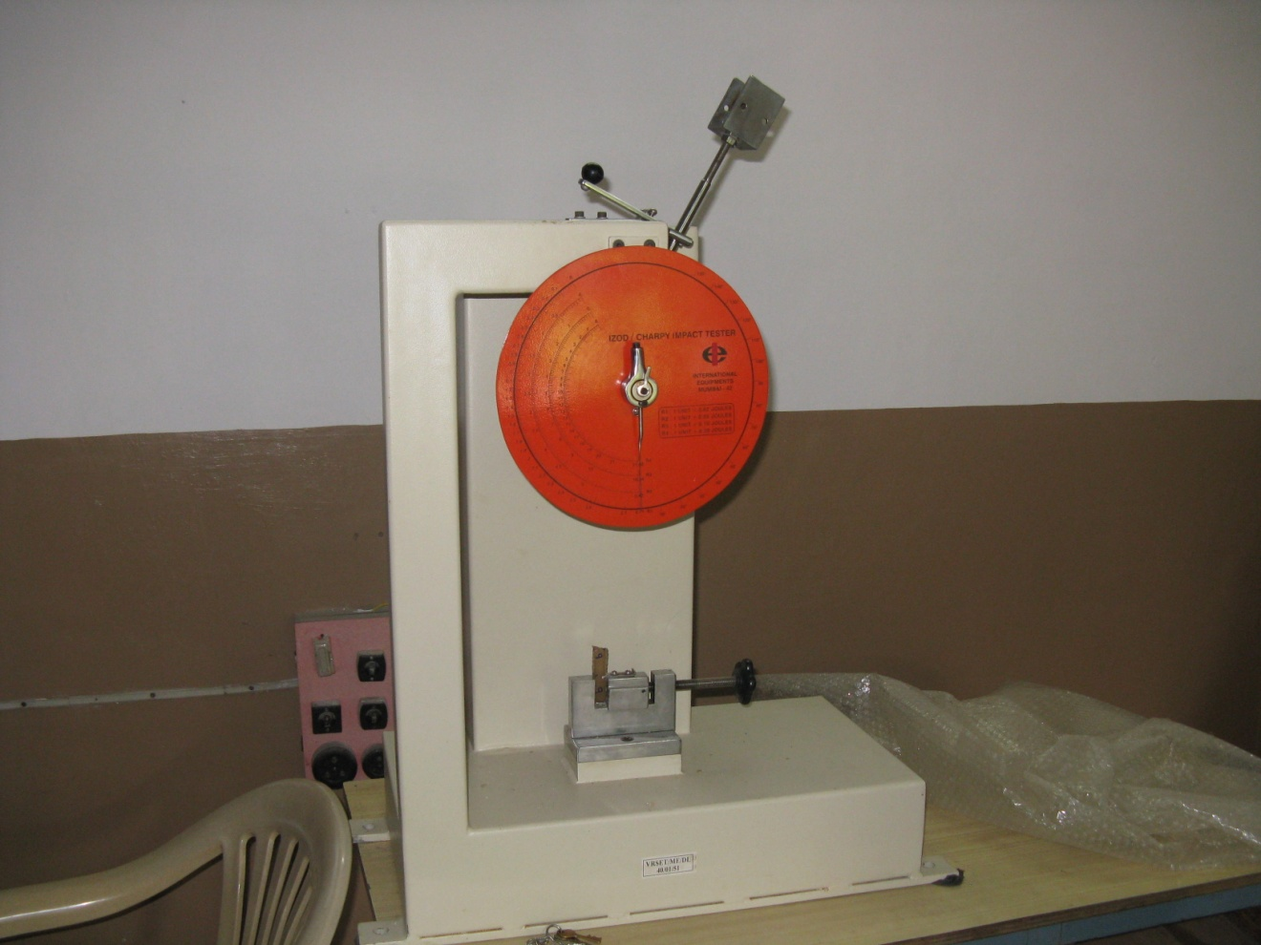
Fig: 3.12 Izod Impact Testing Machine
(With sample in its fixture)
3.3 METHOD FOR EVALUATION OF TENSILE MODULUS FOR COMPOSITES THROUGH SIMULATION:
To evaluate the tensile modulus we used ANSYS software. Modeling is done based on micro-mechanics of composites i.e. one layer is equal to one fiber. The modeling is done so that the contents are same below and above the axis.

Boundary Conditions:-
At one end all the degree of freedom are constrained and at the other end a uniform pressure is applied on the area.

Element Type:-
The element type used is 20-node solid 95
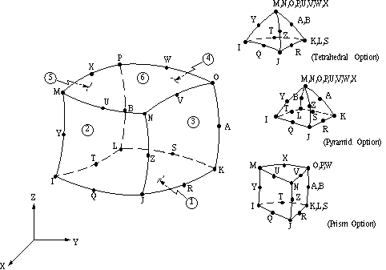
Fig: 3.13 SOLID95 Element

SOLID95 is a higher order version of the 3-D 8-node solid element (SOLID45). It can tolerate irregular shapes without as much loss of accuracy. SOLID95 elements have compatible displacement shapes and are well suited to model curved boundaries. The element is defined by 20 nodes having three degrees of freedom per node: translations in the nodal x, y, and z directions. The element may have any spatial orientation. The element has plasticity, creep, stress stiffening, large deflection, and large strain capabilities. Various printout options are also available. See Section 14.95 of the ANSYS Theory Reference for more details about this element.
The below figure 3.13 represents a sample modeling for a teat sample using micromechanics with specified boundary conditions and loads applied. Figure 3.14 represents a sample deflection in the bar in X-direction when maximum load is applied. In the same way modeling and analysis are done for all the nine samples at continuous steps of load and deflections are noted down to find out young’s modulus.

Fig: 3.14 Sample Model for Tensile Modulus

Fig: 3.15 Sample Analysis of Tensile Sample1

CHAPTER 4
RESULTS AND DISCUSSION

CHAPTER 4
RESULTS AND DISCUSSION

4.1 BEHAVIOR OF COMPOSITES UNDER FLEXURAL LOADING:
For homogeneous material the flexural strength is equal to the tensile strength however for non-homogeneous materials like composites there is a variation in the flexural strength.
Here, the flexural strength is determine based on three-point-bending test conducted as stated in the testing procedures of methods and means in chapter 3. The results obtained from the flexural strength are stated below.

Results from Experimentation on Composites for Flexural Strength:
Test-Sample(composition) | MAXIMUM LOAD(N) | Deflection at maximum load(mm)
Sample-1 | 520 | 3.8
Sample-2 | 901.539 | 8.8
Sample-3 | 933.912 | 8.6
Sample-4 | 1126.188 | 4.2
Sample-5 | 431.64 | 5.2
Sample-6 | 311.958 | 6
Sample-7 | 747.522 | 6.4
Sample-8 | 643.536 | 7
Sample-9 | 123.606 | 8.8
Table: 4.1 Loads and Corresponding Deflection obtained in Experimentation Process for Three-Point Bending Test
Test-Sample | maximum stess(MPa) | strain at maximum load | flexural Modulus(Gpa)
Sample-1 | 242.651331 | 0.0139593 | 14.331
Sample-2 | 420.75 | 0.0323268 | 21.0290226
Sample-3 | 435.86 | 0.0316 | 21.81
Sample-4 | 525.6 | 0.0154287 | 32.83643
Sample-5 | 201.446388 | 0.0191022 | 10.54055612
Sample-6 | 145.591 | 0.022041 | 7.651448802
Sample-7 | 348.8685 | 0.0235104 | 16.44936876
Sample-8 | 300.3382512 | 0.0257145 | 11.45512856
Sample-9 | 57.6869202 | 0.0323268 | 2.648099
Table: 4.2 Stress, Strain and Young’s Modulus obtained in Experimentation Process for Three-Point Bending Test

From, the above values a bar graph is drawn to make the results understandable compared to each other. The bar graph is shown below in figure 4.1.

Fig: 4.1 Variation of the Flexural Modulus with respect to Different Samples Obtained By Experimentation (Three-Point-Bending Test).
Discussion on results of Flexural strength:-
- It is evident from the graphs 4.1 that the Flexural modulus is varying with respect to the composition of the fiber in the respective samples.

- It can also be noted form the above graphs that Flexural modulus by addition of fiber (jute or glass) increases the beyond the young’s modulus of the pure matrix (polyester). So, by addition of fiber to the matrix the stiffness of the total mixture increases.

- It can be concluded that the Flexural modulus varies significantly from tensile modulus for composite of same composition. This is because of the tension and compression occurring simultaneously on the composite in the flexural test.

- From the below graph 4.2 we can conclude that the Flexural modulus of the hybrid samples, sample2 (jute15%; glass10%) &sample 3 (jute 10%; glass 15%) is in-between the Flexural modulus of the sample1 (jute 25%) and sample 4(glass 25%).

- The Flexural modulus of hybrid samples is greater than the Flexural modulus of sample-1(jute 25%) and it is less than Flexural modulus of sample-4(Glass25%). Which indicate the hybrids are stronger and stiffer than 25%-jute sample and are competitive in strength and stiffness to that of 25%-glass sample.

- It can also be concluded that the strength of hybrid samples increases by increasing the volume fraction of the glass in the sample.

Fig: 4.2 Variation of the Flexural Modulus of Composites obtained by Experimentation(Three-Point Bending Test) in Hybrids with Respect to Pure Samples.

- From graph 4.3, which shows the Flexural modulus of samples with 10%, 15% and 25% jute in pure matrix. We can conclude that the Flexural modulus and stiffness of the composite increases by increasing the volume fraction of the jute in the composite.

Fig: 4.3 Variation of the Flexural Modulus by varying the jute content in the pure matrix of Composite Obtained by Experimentation with respect to test samples.
- From graph 4.4, which shows the Flexural modulus of samples with 10%, 15% and 25% glass in pure matrix. We can conclude that the Flexural modulus and stiffness of the composite increases by increasing the volume fraction of the glass in the composite.

Fig: 4.4 Variation of the Flexural Modulus by Varying the Glass Content in the Pure Matrix of Composite Obtained By Experimentation with respect to test samples
(Three-Point-Bending Test).
4.2 BEHAVIOR OF COMPOSITES UNDER IMPACT LOADING:
Impact is a very important phenomenon in governing the life of a structure. For example, in the case of an aircraft, impact can take place by a bird hitting a plane while it is cruising, or during takeoff and landing the aircraft may be struck by debris present on the runway, and as well as other causes.
Izod impact testing is an ASTM standard method of determining impact energy. A notched sample is generally used to determine impact energy. The test is named after the English engineer Edwin Gilbert Izod (1876–1946), who described it in his 1903 address to the British Association, subsequently published in Engineering. An arm held at a specific height (constant potential energy) is released. The arm hits the sample and breaks it. From the energy absorbed by the sample, its impact energy is determined. The results are expressed in energy lost per unit of thickness (such as ft-lb/in or J/cm) at the notch. Alternatively, the results may be reported as energy lost per unit cross-sectional area at the notch (J/m² or ft-lb/in²). The impact strength is calculated from the energy absorbed by dividing the energy absorbed by the area at the notch.
Results from Experimentation on Composites for Impact Strength:
Test-Sample | ENERGY ABSORBED(J or N-M) | IMPACT STRENGTH  (N-M/Sq.mm)
Sample-1 | 5.2 | 0.052
Sample-2 | 12 | 0.12
Sample-3 | 15 | 0.15
Sample-4 | 22 | 0.22
Sample-5 | 3.2 | 0.032
Sample-6 | 2.1 | 0.021
Sample-7 | 12.8 | 0.128
Sample-8 | 8.6 | 0.086
Sample-9 | 0.225 | 0.00225
Table: 4.3 Energy Absorbed and Impact Strength obtained in
Experimentation Process (IZOD impact testing)

Fig: 4.5 Variation of the Energy Absorbed in Joules by Different Samples Obtained By Experimentation (Izod impact testing).

Fig: 4.6 Variation of the Impact strength in ${joules}/{{mm}^{2}}$ by Different Samples Obtained By Experimentation (Izod impact testing).

Discussion on results of Impact strength:-
- It is evident from the graphs 4.6 that the Impact strength is varying with respect to the composition of the fiber in the respective samples.

- It can also be noted form the above graphs that Impact strength by addition of fiber (jute or glass) increases the beyond the Impact strength of the pure matrix (polyester). So, by addition of fiber to the matrix the facture toughness of the total mixture increases.

- It can be concluded that the Impact strength varies significantly by addition of fiber to the matrix.

Fig: 4.7 Variation of the Impact Strength of Composite obtained by Experimentation (Iozd Impact testing) in Hybrids with Respect to Pure Samples.
- From the above graph 4.7 we can conclude that the Impact strength of the hybrid samples, sample2 (jute15%; glass10%) &sample 3 (jute 10%; glass 15%) is in-between the Impact strength of the sample1 (jute 25%) and sample 4(glass 25%).

- The Impact strength of hybrid samples is greater than the Impact strength of sample-1(jute 25%) and it is less than Impact strength of sample-4(Glass25%). Which indicate the hybrids are stronger and more fracture resistant than 25%-jute sample and are competitive in strength and fracture resistance to that of 25%-glass sample.

- It can also be concluded that the Impact strength of hybrid samples increases by increasing the volume fraction of the glass in the sample.

Fig: 4.8 Variation of the Impact Strength by varying the jute content in the pure matrix of Composite Obtained by Experimentation (Izod Impact Strength test).
- From graph 4.8, which shows the Impact strength of samples with 10%, 15% and 25% jute in pure matrix. We can conclude that the Impact strength and facture resistance of the composite increases by increasing the volume fraction of the jute in the composite.

Fig: 4.9 Variation of the Impact Strength by varying the Glass content in the pure matrix of Composite Obtained by Experimentation (IZOD Impact Strength test).
- From graph 4.9, which shows the Impact strength of samples with 10%, 15% and 25% glass in pure matrix. We can conclude that the Impact strength and fracture resistance of the composite increases by increasing the volume fraction of the glass in the composite.

4.3 BEHAVIOR OF COMPOSITES UNDER TENSILE LOADING:
RESULTS FOR TENSILE STRENGTH:-
RESULTS FROM THEORETICAL EVALUATION OF MECHANICAL PROPERTIES FOR COMPOSITES:
The mechanical properties like young’s modulus; Poisson’s ratio and shear modulus are calculated in both longitudinal and transverse direction by using rules of mixture equations stated methods and means of chapter 3.

In Longitudinal Direction: - (young’s modulus and Poisson’s ratio)

Test-sample | longitudinal direction
Test-sample | young’s modulus(GPa) $E_{1}$ | Poisson’s ratio  $$ϑ_{12}$$
Sample-1 | 7.25 | 0.44
Sample-2 | 12.25 | 0.422
Sample-3 | 14.75 | 0.413
Sample-4 | 19.75 | 0.395
Sample-5 | 5.55 | 0.448
Sample-6 | 4.7 | 0.452
Sample-7 | 13.05 | 0.421
Sample-8 | 9.7 | 0.434
Sample-9 | 3 | 0.46
Table: 4.4 young’s modulus ($E_{1}$) and Poisson’s ratio ($ϑ_{12}$) in longitudinal direction obtained by rules of mixture

In Transverse Direction: - (young’s modulus and Poisson’s ratio)

Test-Sample(composition) | transverse direction
Test-Sample(composition) | young'smodulus GPa)  $$E_{2}$$ | Poisson’s ratio  $$ϑ_{21}$$
Sample-1 | 3.809524 | 0.2312
Sample-2 | 3.86207 | 0.1330454
Sample-3 | 3.889 | 0.108892
Sample-4 | 3.944 | 0.07888
Sample-5 | 3.4384 | 0.27755
Sample-6 | 3.2787 | 0.3152123
Sample-7 | 3.51 | 0.1132345
Sample-8 | 3.31754 | 0.1484343
Sample-9 | 3 | 0.46
Table: 4.5 young’s modulus ($E_{2}$) and Poisson’s ratio ($ϑ_{21}$) in transverse direction obtained by rules of mixture

RESULTS FROM EXPERIMENTATION ON COMPOSITES:
The tensile test is conducted on the samples to find out the load and the corresponding deflections in mm by which the stress and strain are found out. A graph for stress Vs strain is drawn which is generally a straight line to some extent and they by curved. By using this graph the actual young’s modulus is determined.
Test-Sample | Ultimate Load(N) | Elongation at  Breaking point (%)
Sample-1 | 3825.9 | 1.8
Sample-2 | 5886 | 2.2
Sample-3 | 7063.2 | 2.4
Sample-4 | 9221.4 | 3
Sample-5 | 2746.8 | 2
Sample-6 | 2354.4 | 1.9
Sample-7 | 6278.4 | 2.42
Sample-8 | 4463.55 | 2.2
Sample-9 | 1471.5 | 2.1
Table: 4.6 ultimate load in Newton’s and elongation
Test-Sample | Breaking Stress(MPa) | Breaking Strain | Young's Modulus(GPa)
Sample-1 | 127.53 | 0.018 | 7.085
Sample-2 | 196.2 | 0.02 | 10.627
Sample-3 | 235.44 | 0.022 | 12.394
Sample-4 | 307.38 | 0.024 | 15.2411
Sample-5 | 91.56 | 0.02 | 5.07366
Sample-6 | 78.48 | 0.02 | 4.2525
Sample-7 | 209.28 | 0.022 | 10.4573
Sample-8 | 148.785 | 0.02 | 8.502
Sample-9 | 49.05 | 0.022 | 2.5
Table: 4.7 Stress, Strain and Young’s modulus in longitudinal direction obtained by experimentation
RESULTS OF EVALUATION OF TENSILE MODULUS FOR COMPOSITES THROUGH SIMULATION:
The loads are applied in steps and corresponding deflection are noted to calculate the stress and strain. From, the value of stress and strain a graph is drawn which is generally a straight line to find out the young’s modulus. The young’s modulus calculated as stated above is:

Test-Sample | Young’s modulus (GPa)
Sample-1 | 7.12
Sample-2 | 11.54869694
Sample-3 | 13.355
Sample-4 | 18.1345
Sample-5 | 5.386
Sample-6 | 4.7
Sample-7 | 12.18
Sample-8 | 9.44
Sample-9 | 3
Table: 4.8 Young’s modulus in longitudinal direction obtained by simulation

Fig: 4.10 Young’s Modulus ($E_{1}$) of Composite Obtained by Rules of Mixture, ANSYS and Experimentation

Fig: 4.11 Variation of Poisson’s ratio ($ϑ_{12}$) in longitudinal direction with respect to test samples.

Fig: 4.12 Variation of Poisson’s ratio ($ϑ_{21}$) in Transverse direction with respect to test samples.
Discussion on results of tensile strength:-
- It is evident from the graphs 4.10, 4.11 and 4.12 that the young’s modulus and Poisson’s ratio in both longitudinal and transverse direction are varying with respect to the composition of the fiber in the respective samples.

- It can also be noted form the above graphs that young’s modulus by addition of fiber (jute or glass) increases the beyond the young’s modulus of the pure matrix (polyester). So, by addition of fiber to the matrix the stiffness of the total mixture increases.

- It can be concluded that the $E_{1}$varies significantly by varying the fiber content in the matrix but $E_{2}$ does not show significant change with respect to change in the fiber content in matrix.

- It also evident that the Poisson’s ratios $ϑ_{12}$ and $ϑ_{21}$ decreased by addition of fiber (jute or glass) to the pure matrix (polyester).

- There is a variation in the results obtained by ANSYS and by rules of mixture because ANSYS considers delaminating effect also into account.

- There is difference between the results obtained from rules of mixture and experimentation because of the manufacturing defects, inclusion, void content and moisture effect.

- From the above graph 4.13 we can conclude that the young’s modulus of the hybrid samples, sample2 (jute15%; glass10%) &sample 3 (jute 10%; glass 15%) is in-between the young’s modulus of the sample1 (jute 25%) and sample 4(glass 25%).

- The young’s modulus of hybrid samples is greater than the young’s modulus of sample-1 and it is less tan young’s modulus of sample-4. Which indicate the hybrids are stronger and stiffer than 25%-jute sample and are competitive in strength and stiffness to that of 25%-glass sample.

- It can also be concluded that the strength of hybrid samples increases by increasing the volume fraction of the glass in the sample.

Fig: 4.13 Variation of the Young’s Modulus ($E_{1}$) of Composite Obtained by Rules of Mixture, ANSYS and Experimentation in Hybrids With Respect to Pure Samples.
- From graph 4.14, which shows the young’s modulus of samples with 10%, 15% and 25% jute in pure matrix. We can conclude that the young’s modulus and stiffness of the composite increases by increasing the volume fraction of the jute in the composite.

Fig: 4.14 Variation of the Young’s Modulus ($E_{1}$) by varying the jute content in the pure matrix of Composite Obtained by Rules of Mixture, ANSYS and Experimentation.
- From graph 4.15, which shows the young’s modulus of samples with 10%, 15% and 25% glass in pure matrix. We can conclude that the young’s modulus and stiffness of the composite increases by increasing the volume fraction of the glass in the composite.

Fig: 4.15 Variation of the Young’s Modulus ($E_{1}$) by varying the glass content in the pure matrix of Composite Obtained by Rules of Mixture, Ansys and Experimentation.
- From graph 4.16 & 4.17 we can conclude that the value of the passions ratios ($ϑ_{12}$& $ϑ_{21}$) of hybrid sample 2 and 3 is in-between the samples of pure jute 1 and pure glass sample 4.
- We can observe that the Poisson’s ratio decreases by increasing the glass content in the hybrid samples.

Fig: 4.16 Variation of the Poisson’s ratio ($ϑ_{12}$) of hybrid Composite Obtained by Rules of Mixture with respect pure sample of glass and jute.

Fig: 4.17 Variation of the Poisson’s ratio ($ϑ_{21}$) of hybrid Composite Obtained by Rules of Mixture with respect pure sample of glass and jute.
- We can also observe that the $ϑ_{12}$ varies significantly by varying the fiber content but where has in $ϑ_{21}$ does not show significant change by variation of fiber content in the matrix.

- We can conclude form the graphs 4.18 and 4.19 in which the jute composition is varied by 10%, 15% and 25% in pure matrix the passions ratio ($ϑ_{12}$& $ϑ_{21}$) decreases with increasing jute content.
- We can conclude similarly to composites in which the glass content is varied by 10%, 15% and 25% in pure matrix the passions ratio ($ϑ_{12}$& $ϑ_{21}$) decreases with increasing glass content.

Fig: 4.18 Variation of the Poisson’s ratio ($ϑ_{12}$) by variation of jute content in the pure matrix Obtained by Rules of Mixture.

Fig: 4.19 Variation of the Poisson’s ratio ($ϑ_{21}$) by variation of jute content in the pure matrix Obtained by Rules of Mixture.

4.4 BEHAVIOR OF COMPOSITES UNDER IN-PLANE SHEAR LOADING:
It had not been possible to test the composites for behavior under shear loading due to the lack of sophisticated equipment to perform the shear test. But the behavior can be predicted by using the equation for in-plane shear modulus discussed in the methods and means of chapter 3 under the rules of mixture.
By using the rules of mixture the shear modulus of different samples are predicted has below.
Shear modulus ($G_{12}$):-
Test-Sample | shear modulus(GPa) $G_{12}$
Sample-1 | 1.753633
Sample-2 | 1.785830393
Sample-3 | 1.802376449
Sample-4 | 1.836405743
Sample-5 | 1.592708988
Sample-6 | 1.522836538
Sample-7 | 1.63281443
Sample-8 | 1.547057905
Sample-9 | 1.4
Table: 4.9 Shear Module’s ($G_{12}$) calculated using rules of mixture

Fig: 4.20 Variation of the Shear modulus ($G_{12}$) by variation of fiber content in the pure matrix Obtained by Rules of Mixture.

Discussion On Results of Shear Loading On Composites:-
- It is evident from the graph 4.11 that by adding the fiber content to the matrix the shear modulus is subjected to rise than that of the pure matrix.
- It can also be concluded that the in-plane shear modulus does not change significantly by adding the fiber content to the matrix.
- From the below graph 4.12 it is evident that the hybrids possessed more shear modulus than the pure jute 25% sample(sample-1) and are competitive to that of pure glass sample (sample-4).
- It also evident that by increasing the glass content in the hybrids the shear modulus of the hybrids also increases.

Fig: 4.21 Variation of the Shear Modulus ($G_{12}$) In Hybrides With Respect To the Pure Samples obtained by Rules of Mixture.

- It can also be conclude that the shear modulus of the sample increase by increase the content of jute (10%, 15% & 25%) or glass (10%,15% &25%) in pure matrix by the values in the table 4.6.

CHAPTER 5
CONCLUSIONS

CHAPTER 5
CONCLUSIONS
It is evident that the young’s modulus, Poisson’s ratio, shear strength, flexural strength and impact strength of the composites are varying with respect to the composition of the fiber in the respective samples. So, we can conclude that the mechanical behavior of the composites vary by varying the fiber content in the composites.

Here we attempt to conclude the mechanical behavior of composites based type of loading and the variation of the results according to the variation of the fiber content.

5.1 Conclusions based on behavior of composites under Flexural loading and Impact loading:-

Here we draw an outline on the behavior of composite under flexural i.e. three-point-bending test. We mainly observe the variation in flexural stiffness with respect to the fiber content in the sample to draw a conclusion about the flexural loading on the composites with different compositions.

- It is evident that the Flexural modulus and impact strength is varying with respect to the composition of the fiber in the respective samples and it can also be noted that Flexural modulus and impact strength by addition of fiber (jute or glass) increases the beyond the flexural modulus and impact strength of the pure matrix (polyester) respectively. So, by addition of fiber to the matrix the stiffness and toughness of the total mixture increases.

- It can be concluded that the Flexural modulus varies significantly from tensile modulus for composite of same composition. This is because of the tension and compression occurring simultaneously on the composite in the flexural test.

- we can conclude that the Flexural modulus and Impact strength of the hybrid samples, sample2 (jute15%; glass10%) &sample 3 (jute 10%; glass 15%) is in-between those of the sample1 (jute 25%) and sample 4(glass 25%) and their respective values of hybrid samples is greater than the those of sample-1(jute 25%) and it is less than those of sample-4(Glass25%). Which indicate the hybrids are stronger, stiffer and more resistant to impact than 25%-jute sample and are competitive in strength, stiffness and toughness to that of 25%-glass sample.

- It can also be concluded that the strength and fracture resistance of hybrid samples increases by increasing the volume fraction of the glass in the sample.

- For samples with 10%, 15% and 25% jute and glass respectively in pure matrix. We can conclude that the Flexural modulus, stiffness, impact strength and facture toughness of the composite increases by increasing the volume fraction of the jute and glass respectively in the composite.

5.2 Conclusions based on behavior of composites under tensile loading:-

Here an outline can be obtained about the ultimate stress and strain at breaking point and also conclusions can be made about the young’s modulus and passions ratio in both longitudinal and transverse direction.
- It can also be noted that young’s modulus by addition of fiber (jute or glass) increases the beyond the young’s modulus of the pure matrix (polyester). So, by addition of fiber to the matrix the stiffness of the total mixture increases.

- It can be concluded that the $E_{1}$varies significantly by varying the fiber content in the matrix but $E_{2}$ does not show significant change with respect to change in the fiber content in matrix based on the results obtained from rules of mixture.

- It also evident that the Poisson’s ratios $ϑ_{12}$ and $ϑ_{21}$ decreased by addition of fiber (jute or glass) to the pure matrix (polyester).

- It is noted that there is a variation in the results obtained by ANSYS and by rules of mixture because ANSYS considers delaminating effect also into account.

- It is noted that there is difference between the results obtained from rules of mixture and experimentation because of the manufacturing defects, inclusion, void content and moisture effect.

- The tensile strength of pure matrix (polyester) when reinforced with Jute and glass uni-directionally in case of hybrid samples, sample 2(jute-15%; glass-10%; resin-75%) and sample 3 (jute-10%; glass-15%; resin-75%) the young’s modulus showed an enormous increase.

- We can conclude that the young’s modulus of the hybrid samples, sample2 (jute15%; glass10%) &sample 3 (jute 10%; glass 15%) is in-between the young’s modulus of the sample1 (jute 25%) and sample 4(glass 25%) and the young’s modulus of hybrid samples is greater than the young’s modulus of sample-1 and it is less tan young’s modulus of sample-4. Which indicate the hybrids are stronger and stiffer than 25%-jute sample and are competitive in strength and stiffness to that of 25%-glass sample.

- It can also be concluded that the strength of hybrid samples increases by increasing the volume fraction of the glass in the sample.

- By observing the young’s modulus of samples with 10%, 15% and 25% jute and glass respectively in pure matrix. We can conclude that the young’s modulus and stiffness of the composite increases by increasing the volume fraction of the jute and glass respectively in the composite.

- We can conclude based on the results obtained by rules of mixture that the value of the passions ratios ($ϑ_{12}$& $ϑ_{21}$) of hybrid sample 2 and 3 is in-between the samples of pure jute 1 and pure glass sample 4 and we can also observe that the Poisson’s ratio decreases by increasing the glass content in the hybrid samples.
- We can also observe that the $ϑ_{12}$ varies significantly by varying the fiber content but where has in $ϑ_{21}$ does not show significant change by variation of fiber content in the matrix.

- We can conclude that jute and glass composition is varied by 10%, 15% and 25% in pure matrix respectively the passions ratio ($ϑ_{12}$& $ϑ_{21}$) decreases with increasing jute and glass content respectively.

5.3 Conclusions based on behavior of composites under Shear loading:-

- It is evident that by adding the fiber content to the matrix the shear modulus is subjected to rise than that of the pure matrix.
- It can also be concluded that the in-plane shear modulus does not change significantly by adding the fiber content to the matrix.
- It is evident that the hybrids possessed more shear modulus than the pure jute 25% sample (sample-1) and are competitive to that of pure glass sample (sample-4) and it also evident that by increasing the glass content in the hybrids the shear modulus of the hybrids also increases.
- It can also be conclude that the shear modulus of the sample increase by increase the content of jute (10%, 15% & 25%) or glass (10%,15% &25%) in pure matrix

The conclusions for the based on tensile modulus, flexural modulus and impact test have been backed up by the experimental investigation but the conclusions based on the shear modulus and Poisson’s ratio have been stated based on the rules of mixtures only.

5.4 SCOPE FOR FUTURE WORK:-

- In this investigation the fibers are oriented axially in uni-directional manner along the length continuously but the orientation of the fiber angle can be changed to different angles like -45, +45 etc... and tested for the mechanical behavior of the composites.
- The composites can be investigated for the cyclic loading, compressive strength and for fatigue strength.
- The reinforcements of the present research work, which are jute and glass, can be changed and an investigation can be carried out.
- The matrix can be changed an different matrixes can be used and investigated to determine the optimal one with more strength.
- The maximum fiber content used in the present research work is 25%. This can be increased to determine the change in the strength of composite with respect to the variation of the fiber content. So, has to determine the maximum possible fiber content and optimum fiber content that a composite can posses.
- The natural fiber when alkali treated increases their strength. So, the composites can be reinforced with these alkali treated fibers to study their mechanical behavior.

REFERENCES:-
- Y. Cao, S. Shibata, I. Fukumoto, Mechanical properties of biodegradable composites reinforced with bagasse fibre before and after alkali treatments, Composites: Part A 37 (2006) 423–429.
- P. Muhammad, M.S. Mohini, Carbon storage potential in natural fiber composites, Resource Conservation and Recycling, 139, (2003), 325.
- M.J. John, R.D. Anandjiwala, Recent Developments in Chemical Modification and Characterization of Natural Fiber-Reinforced Composites, Polymer Composites, 29(2), (2008). 187-207.
- K. G. Satyanarayana, K. Sukumaran, P. S. Mukherjee, C. Pavithran, S. G. K Pillai, Natural Fiber-Polymer Composites, Cement and Concrete Composites, 12(2), (1990), 117-136.
- K. G. Satyanarayana, K. Sukumaran, A. G. Kulkarni, S. G. K. Pillai, P. K. Rohatgi, Fabrication and Properties of Natural Fiber-Reinforced Polyester Composites, Composites, 17(4), (1986), 329-333.
- M .A. Mansur, M. A. Aziz, Study of Bamboo-Mesh Reinforced Cement Composites, Int. Cement Composites and Lightweight Concrete, 5(3), (1983),165-171.
- . L. Lundquist, B.Marque, P. O. Hagstrand, Y. Leterrier, J. A. E. Månson, Novel Pulp Fiber Reinforced Thermoplastic Composites”, Composites Science and Technology, 63(1), (2003), 137-152.
- L. A. Pothana, Z. Oommenb, S. Thomas, Dynamic Mechanical Analysis of Banana Fiber Reinforced Polyester Composites, Composites Science and Technology, 63(2), (2003), 283-293.
- Luo S. and Netravali A.N., (1999). Mechanical and thermal properties of environmentally friendly green composites made from pineapple leaf fibres and poly (hydroxybutyrate-co-valerate) resin, Polymer Composites, 20(3), pp. 367-378.
- Pavithran C., Mukherjee P.S., Brahmakumar M. and Damodaran A.D., (1987). Impact properties of natural fibre composites, Journal of Materials Science Letters, 6(8), pp. 882-884.
- Karmaker A.C. and Schneider J.P., (1996). Mechanical Performance of Short Jute Fiber Reinforced Polypropylene, Journal of Materials Science Letters, 1996, 15(3), pp. 201-202.

